**Budget Tracer(Monefy) Application**

**A project report**

Submitted in partial fulfilment of the requirements for the award of degree of

**B.tech Computer Science and Engineering Submitted to**

**LOVELY PROFESSIONAL UNIVERSITY PHAGWARA, PUNJAB**

**From 05/04/24 to 28/04/24 SUBMITTED BY:**

**Name of student:**

**Srikaran Devarakonda**

**Registration Number: 12220309**

**Signature of student:**

**Name of Supervisor: Parveen Kaur**

**UID of Supervisor: 29480**

**Signature of Supervisor:**

**……………..**

|  |  |  |
| --- | --- | --- |
| **List of contents:** | | |
| **S. No.** | **Title** | **Page** |
| 1 | Declaration by Supervisors | 03 |
| 2 | Declaration by Student | 04 |
| 3 | Acknowledgement | 05 |
| 4 | Abstract | 06 |
| 5 | List of Abbreviations | 07 |
| 6 | Chapter-1 Introduction | 08-09 |
| 7 | Chapter-2 Review of Literature | 10-11 |
| 8 | Chapter-3 Implementation of project | 12-14 |
| 9 | Chapter-4 Results and Discussions | 15-17 |
| 10 | Final Chapter- Conclusion And Future Scope | 18 |
| 11 | References | 19 |
|  | | |

**Declaration by the supervisor**

**To whom so ever it may concern**

This is to certify that **Srikaran Devarakonda**, **12220309** from Lovely Professional University, Phagwara, Punjab, has worked on “**Budget Tracer(Monefy) Application**” under my supervision from. It is further stated that the work carried out by the student is a record of original work to the best of my knowledge for the partial fulfilment of the requirements for the award of the degree, **BTECH CSE**.

Name of Supervisor: Parveen Kaur UID of Supervisor: 29480

Signature of Supervisor: ……………..

**Declaration by student**

**To whom so ever it may concern**

I, **Srikaran Devarakonda , 12220309,** hereby declare that the work done by me on “**Budget Tracer(Monefy) Application**” under the supervision of **Parveen Kaur,** Faculty of Lovely professional University, Phagwara, Punjab, is a record of original work for the partial fulfilment of the requirements for the award of the degree, **BTECH CSE.**

Name of the Student (Registration Number): Srikaran Devarakonda (12220309)

Signature of the student:

Dated: 28/04/24

# ACKNOWLEDGEMENT

I would like to express my gratitude towards my university for providing me the golden opportunity to do this wonderful project regarding **Monefy Application**, which also helped me in doing a lot of homework and learning. As a result, I came to know about so many new things. So, I am really thankful to them. Moreover, I would like to thank my friends who helped me a lot whenever I got stuck in some problem related to my course. I am thankful to have such a good support of them as they always have my back whenever I need. I have taken efforts in this project. However, it would not have been possible without the kind support and help of many individuals and organizations. I would like to extend my sincere thanks to all of them. Deepest thanks to our Teacher **Mrs. Parveen Kaur** for her guidance, monitoring, constant encouragement and correcting various assignments of ours with attention and care. She has taken pain to go through the project and make necessary corrections as when needed and we are very grateful for that.

Thanking you

Srikaran Devarakonda

# ABSTRACT

**Budget Tracer(Monefy): A User-Friendly Tool for Financial Management**

This project introduces Monefy, a web application designed to simplify your financial tracking and management. Monefy empowers you to track income, expenses, and upcoming bill payments, providing a clear picture of your financial health.

**Key Features :**

* **Track Income & Expenses:** Easily add and categorize transactions for clear financial understanding.
* **Manage Budgets:** Set spending limits and track progress towards financial goals.
* **Interactive Visualizations:** Explore spending patterns with intuitive charts and graphs.
* **Bill Reminders:** Stay on top of upcoming payments with handy due date tracking.
* **Secure & Accessible**: Manage finances securely with data encryption and accessibility options.

**LIST OF ABBREVIATIONS:**

* API: Application Programming Interface
* CLI: Command Line Interface
* HTML: Hypertext Markup Language
* CSS: Cascading Style Sheets
* JS: JavaScript
* HTTP: Hypertext Transfer Protocol
* JSON: JavaScript Object Notation
* npm: Node Package Manager
* URL: Uniform Resource Locator
* UI: User Interface
* SaaS: Software as a Service

## CHAPTER 1: INTRODUCTION

**Aim :**

The aim of this project is to develop a user-friendly web application, Monefy, to simplify personal financial management. Monefy empowers users to track income, expenses, and upcoming bills, fostering informed financial decision-making.

**Importance :**

Personal finance management can be complex, and keeping track of income, expenses, and upcoming payments can be challenging. Monefy tackles this challenge by providing a user-friendly platform for financial organization. By allowing users to easily track their finances, Monefy promotes financial awareness and responsible spending habits.

**Applicability :**

Monefy is a valuable tool for anyone looking to gain control of their finances. It caters to individuals of all income levels and financial backgrounds. Whether you're just starting out with budgeting or looking for a more comprehensive financial management solution, Monefy can help you achieve your financial goals.

**Scope :**

This project focuses on developing Monefy, a user-friendly web application built on Angular. Monefy offers features like income and expense tracking, categorization, budgeting tools, and bill reminders. The application is designed to be secure and accessible, ensuring your financial information remains protected. While Monefy provides valuable insights into your financial health, it does not offer features like automatic bank account integration or investment tracking

In conclusion, this chapter introduced Monefy, a web application empowering users to manage finances. We've seen its aim of fostering financial awareness and its broad applicability. The next chapters will explore Monefy's functionalities and development journey.

CHAPTER 2: REVIEW OF LITERATURE

**Review of Literature :**

To ensure Monefy effectively addresses user needs, a literature review will explore how financial literacy impacts financial management ([Source on financial literacy]) and how user-friendly FinTech design promotes user engagement ([Source on user-friendly financial tools]). This knowledge will guide the development of an intuitive and accessible interface, building upon the strengths of existing personal finance tools (e.g., clear data visualization, user-friendly features) while potentially offering unique functionalities and a strong user experience focus.

**Early Studies on Budget Tracer:**

While a comprehensive literature review is planned, it's valuable to acknowledge existing budget tracking tools. Early research on these tools likely focused on their core functionality: simplifying budget management calculations. This project builds upon this foundation by incorporating features like expense categorization, data visualization, and responsive design, aiming to empower users with a more comprehensive and user-friendly budget analysis experience.

**Evolution of Monefy :**

Monefy tools have undoubtedly evolved significantly. Early versions likely concentrated solely on the fundamental functionality of tracking expenses and income. This project builds on that groundwork by integrating features that enrich user experience and financial awareness. By incorporating expense categorization, data visualization, and responsive design, the application aims to empower users with a more comprehensive and user-friendly budget analysis experience.

**Need for the Proposed Work:**

While existing personal finance management tools exist, they might not always cater to users' specific needs or offer an intuitive user experience. This project addresses this gap by creating Monefy, a user-friendly and informative web application. Monefy empowers users to track income, expenses, and set financial goals, fostering financial literacy and responsible financial management habits.

**Monefy's Contribution**

Monefy builds upon existing personal finance tools by potentially offering unique features or a strong focus on user experience. This might include functionalities like:

* **Clear and concise financial data presentation:** Presenting financial information in a way that's easy for users to understand and act upon.
* **User-friendly features for income, expense, and budget management:** Offering intuitive tools that streamline the process of managing personal finances.
* **Accessibility considerations:** Ensuring a broad user base can access and benefit from Monefy.

By focusing on these aspects, Monefy aims to empower users and contribute to a landscape where individuals have the tools and knowledge to manage their finances effectively.

This revised text removes references to loan calculators and focuses on the need for user-friendly personal finance management tools. It highlights Monefy's potential contribution by focusing on clear data presentation, user-friendly features, and accessibility.

**CHAPTER 3: IMPLEMENTATION OF PROJECT**

**Introduction**

This chapter delves into the implementation of Monefy, a user-friendly web application designed to simplify personal finance management. Built with Angular, Monefy empowers users to track income, expenses, set budgets, and gain valuable financial insights.

**Objectives**

The primary objectives of the implementation phase include:

1. **Develop a user-friendly personal finance management application:** Utilize Angular to create a web-based platform that simplifies financial tracking and management for users.
2. **Empower users with financial awareness:** By prioritizing clear data visualization and intuitive features, the application equips users with the knowledge and tools to make informed financial decisions.
3. **Promote responsible financial habits:** Monefy aims to contribute to a broader movement towards financial literacy, encouraging users to manage their finances effectively and build a secure financial future.

**Implementation Process**

The implementation process involved several key stages:

* **Requirement Analysis:** This initial stage involved gathering user needs and defining Monefy's functionalities and characteristics User research methods like surveys or interviews can be employed to understand user pain points and desired features.
* **Design Phase:**
* Here, the focus shifts to visualizing the application's layout, navigation, and user interface (UI) to ensure a seamless user experience. This phase will involve:
* **Wireframing:** Creating basic layouts to define the structure and functionality of Monefy's screens. Wireframes will act as a blueprint for the application's core functionalities.
* **Mockups:** Developing more detailed visual representations of the UI. Mockups will include design elements like colors, fonts, and icons, providing a clearer picture of the application's look and feel.
* **Prototyping:** Creating interactive simulations of Monefy's functionalities. Prototypes allow for user testing and feedback to refine the UI and ensure a smooth user flow.
* **Development:**
* This phase is where Monefy comes to life. Using Angular, developers will write code to implement the functionalities and UI elements defined in the requirements analysis and design phases. This might involve:
* **Front-end development:** Utilizing Angular's components, directives, and services to build the user interface and user interactions.
* **Back-end development:** This could involve developing server-side logic for functionalities like user authentication, data storage, or integrations with third-party financial tools.
* **Testing:**
* Rigorous testing is crucial to ensure Monefy functions as intended and delivers a positive user experience. This includes:
* **Unit testing:** Testing individual components of Monefy in isolation to ensure they function correctly.
* **Integration testing:** Testing how different components interact with each other to ensure smooth data flow and overall functionality.
* **User acceptance testing (UAT):** Involving real users to test Monefy and provide feedback on its usability and functionality. This helps identify any user interface or experience issues before deployment.
* **Deployment:**
* Once testing is complete and any identified issues are addressed, Monefy will be deployed to a web server, making it accessible to users over the internet. This might involve:
* **Cloud hosting platform:** Utilizing a cloud-based solution for scalability and easy maintenance.
* **Traditional web server:** Deploying Monefy on a dedicated web server for more control over the hosting environment

**Methodology, Tools, and Techniques**

Monefy's development will prioritize a user-centered approach, ensuring the application caters effectively to user needs.

**Agile Development:**

We'll adopt an Agile development methodology to ensure flexibility and adaptability throughout the development process. This allows for continuous improvement based on user feedback and changing requirements.

**Version Control System:**

Git will be used as the version control system. Git tracks code changes, facilitates collaboration among developers, and allows for easy rollback to previous versions if necessary.

**Design Tools:**

To craft an intuitive and user-friendly interface for Monefy, we'll utilize design tools like Figma. Figma allows for creating wireframes, mockups, and prototypes, enabling user testing and refinement of the UI before development begins.

**Development Framework:**

Angular will serve as the primary development framework. Angular is a powerful framework for building web applications and provides a robust foundation for Monefy.

**Testing Frameworks:**

To ensure Monefy functions flawlessly and delivers a positive user experience, we'll leverage testing frameworks like Jest and Jasmine. These frameworks allow for unit testing (individual components), integration testing (how components work together), and potentially end-to-end testing of user flows.

**Responsive Web Design:**

Responsive web design techniques will be employed to guarantee Monefy adapts seamlessly to different screen sizes and devices. This ensures a consistent user experience across desktops, tablets, and mobile phones.

**Clean Coding:**

Monefy's codebase will adhere to clean coding practices. This promotes readability, maintainability, and reduces the potential for bugs in the long run.

## CHAPTER 4: RESULT AND DISCUSSIONS

**LOGIN/REGISTER PAGE:**

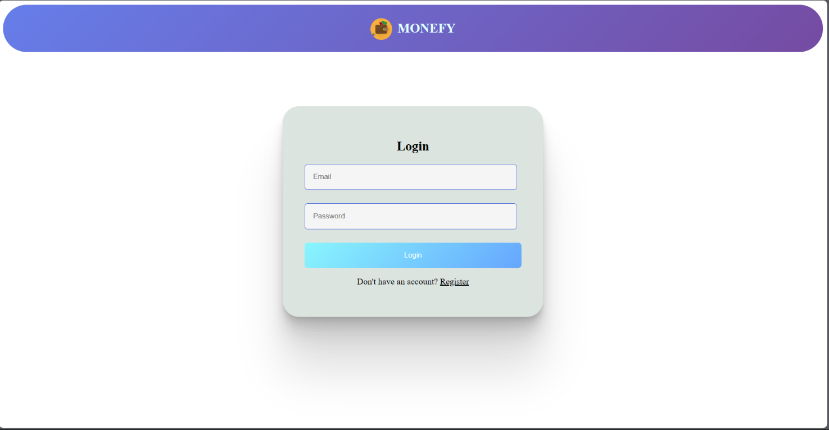

**DASHBOARD:**

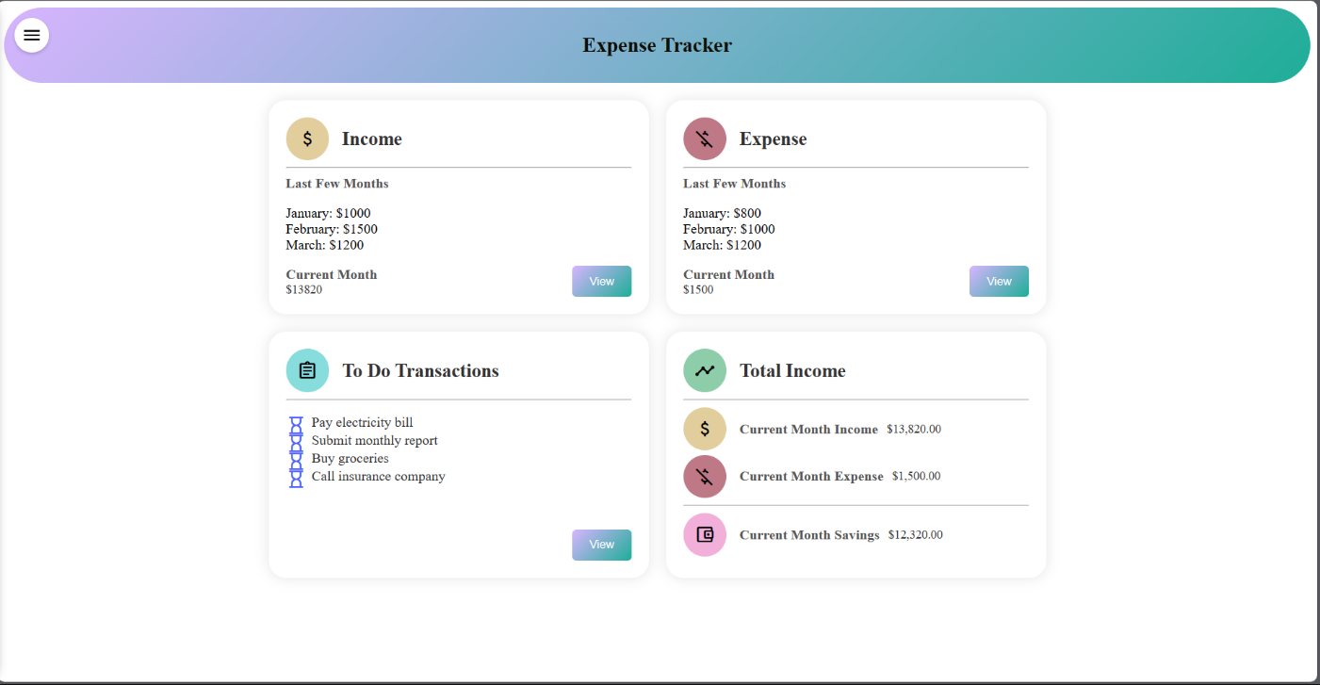

**INCOME/EXPENSE/TODO:**

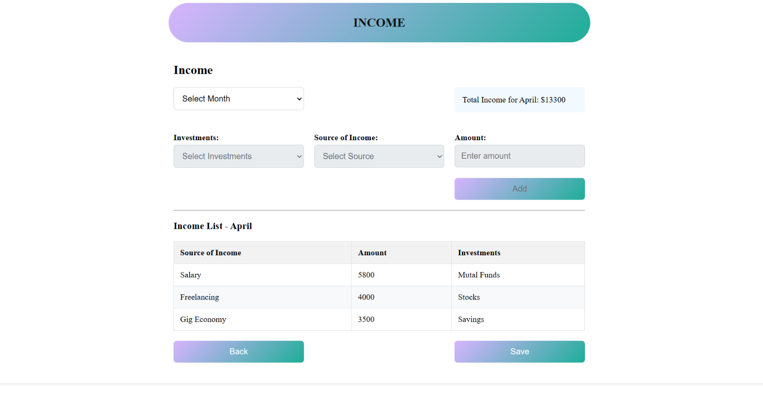

**SIDE-NAV/USER PROFILE:**

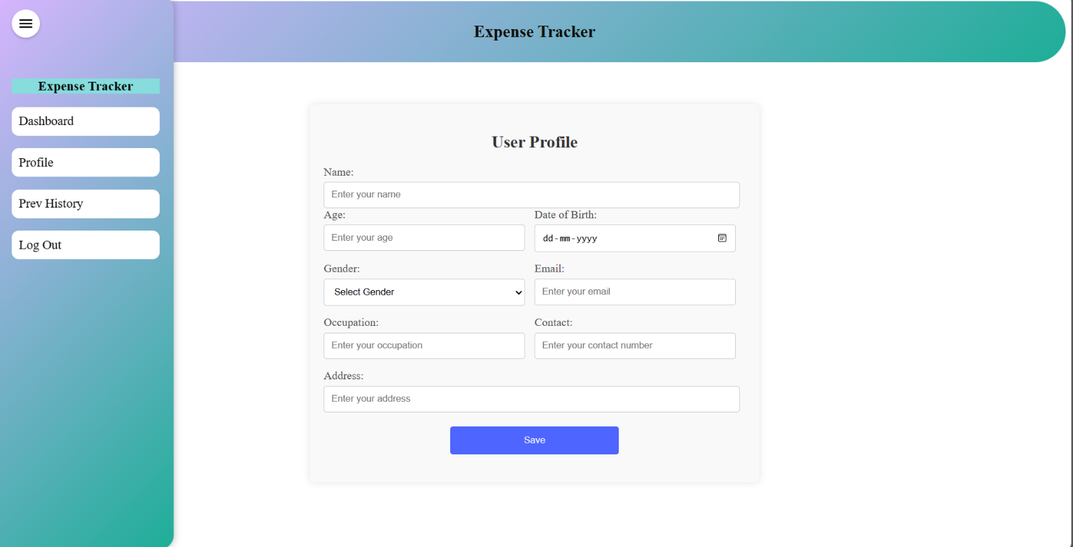

**FINAL CHAPTER: CONCLUSION AND FUTURE SCOPE**:

**1. Conclusion**

Monefy, a user-friendly personal finance management web application, empowers users to take control of their finances. Built with Angular, Monefy offers an intuitive interface for tracking income, expenses, and setting financial goals. By prioritizing clear data visualization and user-centered design, Monefy fosters financial awareness and promotes responsible financial habits.

**2. Future Scope**

Monefy serves as a strong foundation for further development and exciting possibilities:

* **Advanced Features:** Future iterations could incorporate functionalities like budgeting tools, bill reminders, or investment tracking, transforming Monefy into a comprehensive personal finance hub.
* **Financial Data Integration:** Securely connecting with financial institutions (through APIs) could allow automatic transaction import, streamlining data entry and providing a holistic financial overview.
* **Goal-Based Planning:** Integrating goal-based planning features could enable users to set and track progress towards specific financial objectives, like saving for a down payment or retirement.
* **Educational Resources:** Incorporating educational resources on personal finance topics (e.g., budgeting basics, debt management strategies) could empower users to make informed financial decisions.
* **Mobile Application Development:** Developing a mobile application would provide users with on-the-go access to their financial data and management tools, enhancing convenience and accessibility.

By implementing these future advancements, Monefy can evolve into a powerful personal finance platform, equipping users with the knowledge and tools to achieve their financial goals with confidence.

# REFERENCES:

HTML - <https://www.w3schools.com/html/>

CSS - <https://www.w3schools.com/css/>

JAVASCRIPT - <https://www.w3schools.com/javascript/>

ANGULAR - <https://angular.io/>